**log(length) v/s birth rates**

* Birth rates between 0 and 10, incrementing by 0.1. Each birth rate iterated 100 times

￼￼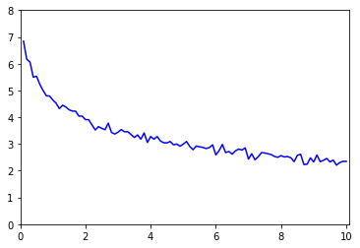￼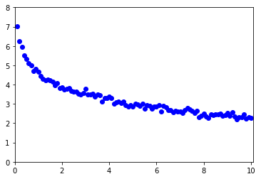

* Birth rates between 0 and 10, incrementing by 0.1

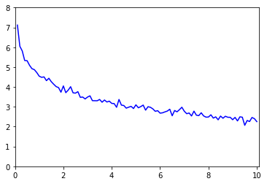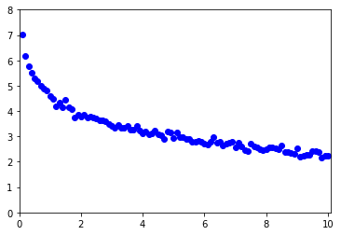

* Birth rates between 0 and 0.1, incrementing by 0.0001

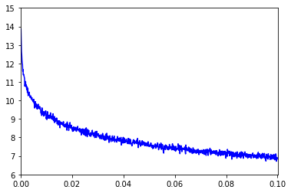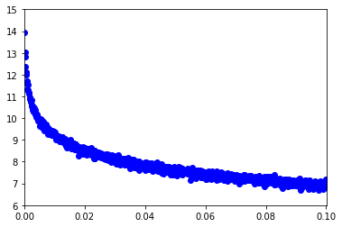

* Birth rates between 0 and 0.01, incrementing by 0.00001

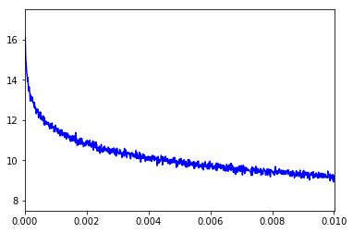

Although most length v/s birth rate graphs look exponential, the logarithmic graphs are not linear. The trends seem to be unchanged by the magnitudes of the birth rates.

The graphs look more like a hyperbola centered on the x-axis and a x=-a, but the trends seem to get more linear in the later iterations.

This is a graph where I don’t take average length and plot all data

